DOCKER ASSIGENMENT NO -3 : WE HAVE 3 CONTAINER 2 (C1 N C2) ARE IN DEFALT BRIDGE N/W & C3 IN CUSTOM NETWROK –TASK IS ESTABLISH CONNECTION BETWEEN C3 N C2 CONTAINER.

STEP 1 : INSTALL DOCKER

Yum install docker –y

Systemctl start docker

Systemctl enable docker

STEP 2: IN DOCKER ‘0’ NETWORK WE CREATE TWO CONTAINER

i.e. C1 AND C2 both are on bridge n/w

STEP 3 : CREATE CUSTOM N/W – ANJALI

#docker network create anjali # create custom n/w.

in that we create c3 container

# docker run -it --name c3 --network anjali centos bash

# docker ps

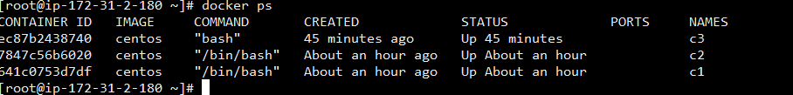

#docker network connect --help

# docker network connect --link c3 anjali c2 # add c2 container in c3 i.e custom n/w

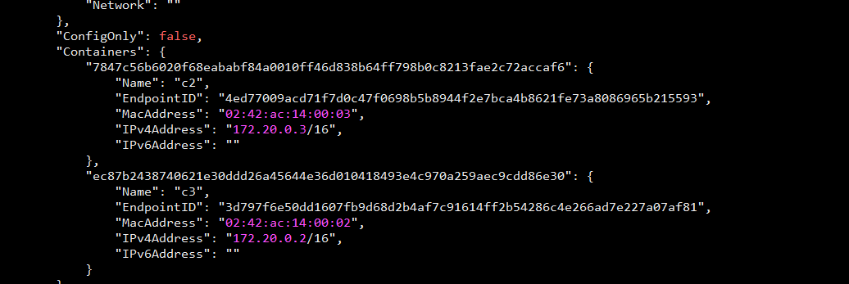

# docker network ls

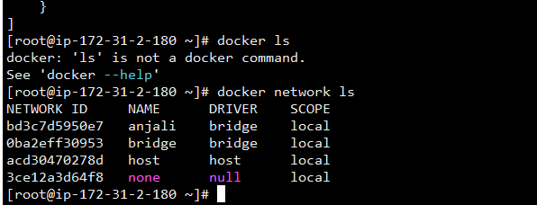

# Here we can ping c3 to c2 …both are in different network ..

